Unit – 3: Network Layer

The Internet Protocol (IP): Forwarding and Addressing in the Internet
- The Internet‟s network layer has three major components.
  - The first component is the IP protocol.
  - The second component is the routing component, which determines the path a datagram follows from source to destination.
  - The final component is a facility to report errors in datagrams and respond to requests for certain network-layer information.

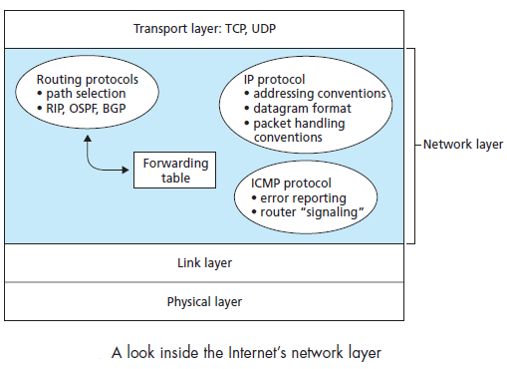
Figure 7

Datagram Format
- IPv4 datagram format is shown in Figure 8. The key fields in the IPv4 datagram are the following:
  - Version number. These 4 bits specify the IP protocol version of the datagram. The datagram format for the current version of IP, IPv4, is shown in Figure 8.
  - Header length. As IPv4 datagram can contain a variable number of options, the 4 bits are needed to determine where in the IP datagram the data actually begins. Most IP datagrams do not contain options and hence IP datagram has a 20-byte header.
  - Type of service. The type of service (TOS) bits was included in the IPv4 header to allow different types of IP datagrams to be distinguished from each other. For example, it might be useful to distinguish real-time datagrams from non-real-time traffic
  - Datagram length. This is the total length of the IP datagram (header plus data), measured in bytes.
  - Identifier, flags, fragmentation offset. These three fields are used with called IP fragmentation.
  - Time-to-live. The time-to-live (TTL) field is included to ensure that datagrams do not circulate forever in the network. This field is decremented by one each time the datagram is processed by a router. If the TTL field reaches 0, the datagram must be dropped.
  - Protocol. This field is used only when an IP datagram reaches its final destination. The value of this field indicates the specific transport-layer protocol to which the data portion of this IP datagram should be passed. For example, a value of 6 indicates that the data portion is passed to TCP, while a value of 17 indicates that the data is passed to UDP.
  - Header checksum. The header checksum helps a router in detecting bit errors in a received IP datagram. The header checksum is computed by treating each 2 bytes in the header as a number and summing these numbers using 1s complement arithmetic. The 1s complement of this sum, known as the Internet checksum, is stored in the checksum field.
  - Source and destination IP addresses. When a source creates a datagram, it inserts its IP address into the source IP address field and inserts the address of the ultimate destination into the destination IP address field.
  - Options. The options fields allow an IP header to be extended.
  - Data (payload).The data field of the IP datagram contains the transport-layer segment (TCP or UDP) to be delivered to the destination.
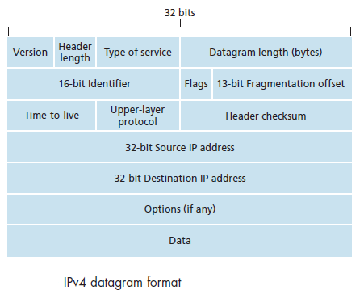
Figure 8

IP Datagram Fragmentation
- The maximum amount of data that a link-layer frame can carry is called the maximum transmission unit (MTU). Suppose an IP datagram is received from one link and the outgoing link has an MTU that is smaller than the length of the IP datagram.
- Here the data in the IP datagram is fragmented into two or smaller IP datagrams encapsulate each of these smaller IP datagrams in a separate link-layer frame and send these frames over the outgoing link.
- Each of these smaller datagrams is referred to as a fragment. Fragments need to be reassembled before they reach the transport layer at the destination.
- To allow the destination host to perform these reassembly tasks, the designers of IP (version 4) put identification, flag, and fragmentation offset fields in the IP datagram header.
- When a datagram is created, the sending host stamps the datagram with an identification number as well as source and destination addresses.
- When the destination receives a series of datagrams from the same sending host, it examines the identification numbers of the datagrams to determine which of the datagrams fragments of the same larger datagram.
- The last fragment has a flag bit set to 0 in order to make sure that the destination has received the last fragment of the original datagram whereas all the other fragments have this flag bit set to 1.
- The offset field is used to specify where the fragment fits within the original IP datagram.
- Figure 9 illustrates an example where a datagram of 4,000 bytes (20 bytes of IP header plus 3,980 bytes of IP payload) arrives at a router and must be forwarded to a link with an MTU of 1,500 bytes.
- The 3,980 data bytes in the original datagram must be allocated to three separate fragments.
- The characteristics of the three fragments are shown in figure 10.

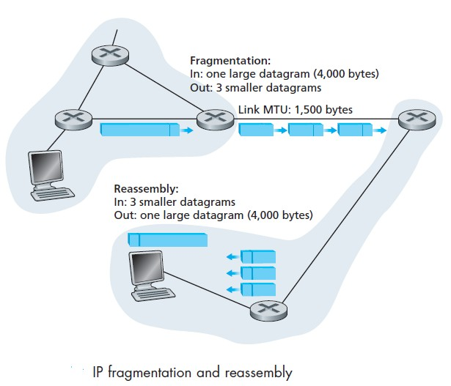
Figure 9
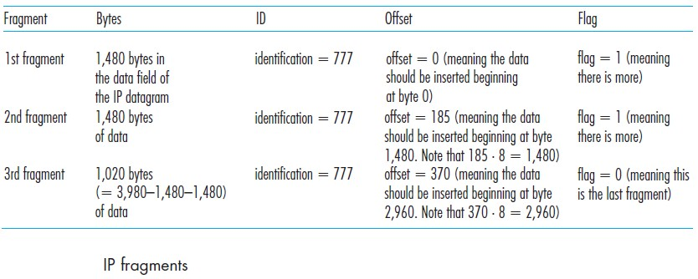
Figure 10

IPv4 Addressing
- Each IP address is 32 bits long and there are thus a total of 2³² possible IP addresses. Figure 11 provides an example of IP addressing and interfaces.
- These addresses are written in so-called dotted-decimal notation.
- Example: IP address 193.32.216.9 (binary format : 11000001 00100000 11011000
00001001)
- One router (with three interfaces) is used to interconnect seven hosts. The three hosts in the upper-left portion of Figure 11, and the router interface to which they are connected have an IP address of the form 223.1.1.xxx.
- The four interfaces are also interconnected to each other by a network that contains no routers. This network interconnecting three host interfaces and one router interface forms a subnet.
- IP addressing assigns an address to this subnet: 223.1.1.0/24, where the /24 notation, sometimes known as a subnet mask, indicates that the leftmost 24 bits of the 32-bit quantity define the subnet address.
- The subnet 223.1.1.0/24 thus consists of the three host interfaces (223.1.1.1, 223.1.1.2, and 223.1.1.3) and one router interface (223.1.1.4).
- There are two additional subnets shown in Figure 11: the 223.1.2.0/24 network and the 223.1.3.0/24 subnet.
- Figure 12 illustrates the three IP subnets present in Figure 11.
- To determine the subnets, detach each interface from its host or router, creating islands of isolated networks, with interfaces terminating the end points of the isolated networks.
- Each of these isolated networks is called a subnet.
- The Internet‟s address assignment strategy is known as Classless Interdomain Routing (CIDR).
- As with subnet addressing, the 32-bit IP address is divided into two parts and again has the dotted-decimal form a.b.c.d/x, where x indicates the number of bits in the first part of the address.
- The x most significant bits of an address of the form a.b.c.d/x constitute the network portion of the IP address, and are often referred to as the prefix.

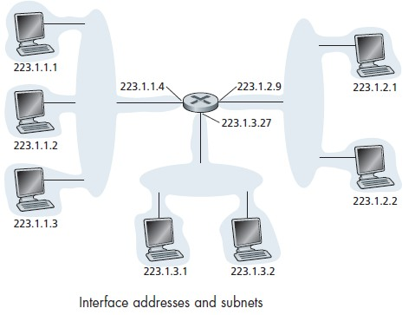
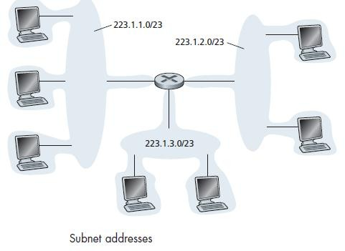
Figure 11 figure 12

Obtaining a Block of Addresses
- A network administrator might first contact its ISP in order to obtain a block of IP addresses for use within an organization‟s subnet
- ISP would provide addresses from a larger block of addresses that had already been allocated to it.
- For example, the ISP may itself have been allocated the address block 200.23.16.0/20.
- The ISP could divide its address block into eight equal-sized contiguous address blocks and give one of these address blocks out to each of up to eight organizations, as shown below.

ISP‟s block 200.23.16.0/20 11001000 00010111 00010000 00000000
Organization 0 200.23.16.0/23 11001000 00010111 00010000 00000000
Organization 1 200.23.18.0/23 11001000 00010111 00010010 00000000
Organization 2 200.23.20.0/23 11001000 00010111 00010100 00000000
……………………………………………………………………………………. Organization 7 200.23.30.0/23 11001000 00010111 00011110 00000000

Obtaining a Host Address: the Dynamic Host Configuration Protocol
- Dynamic Host Configuration Protocol (DHCP) allows a host to obtain an IP address automatically.
- It is referred as a plug-and-play protocol. It is a client-server protocol.
- For a newly arriving host, the DHCP protocol is a four-step process, as shown in Figure 14 for the network setting shown in Figure 13.
- The four steps are:
  - DHCP server discovery: The first task of a newly arriving host is to find a DHCP server. This is done using a DHCP discover message, which a client sends within a UDP packet to port 67. The UDP packet is encapsulated in an IP datagram. The DHCP client creates an IP datagram containing its DHCP discover message along with the broadcast destination IP address of 255.255.255.255 and a “this host” source IP address of 0.0.0.0. The DHCP client passes the IP datagram to the link layer, which then broadcasts this frame to all nodes attached to the subnet.
  - DHCP server offer(s): A DHCP server receiving a DHCP discover message responds to the client with a DHCP offer message that is broadcast to all nodes on the subnet, again using the IP broadcast address of 255.255.255.255. Each server offer message contains the transaction ID of the received discover message, the proposed IP address for the client, the network mask, and an IP address lease time.
  - DHCP request: The newly arriving client will choose from among one or more server offers and respond to its selected offer with a DHCP request message.
  - DHCP ACK: The server responds to the DHCP request message with a DHCP ACK message, confirming the requested parameters.
- Once the client receives the DHCP ACK, the interaction is complete and the client can use the DHCP-allocated IP address for the lease duration.

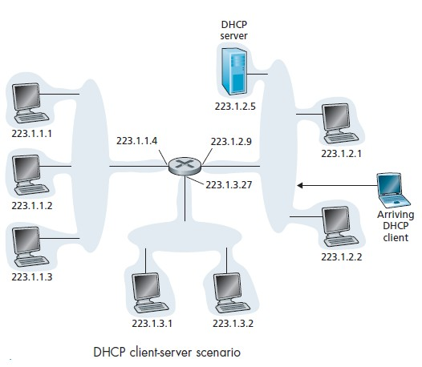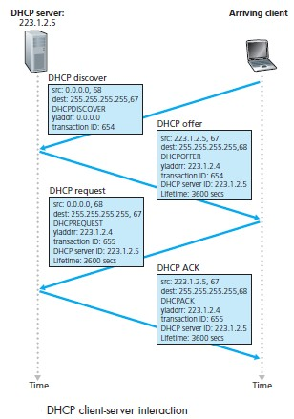
Figure 13 Figure 14

Network Address Translation (NAT)
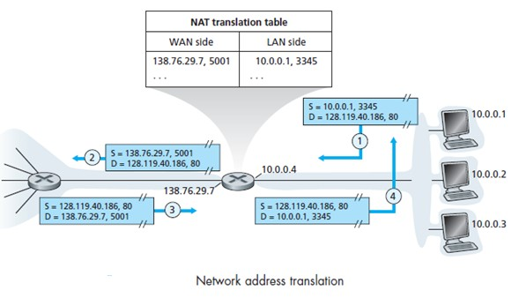
Figure 15
- Figure 15 shows the operation of a NAT-enabled router. The NAT-enabled router, residing in the home, has an interface that is part of the home network.
- All four interfaces in the home network have the same subnet address of 10.0.0/24. The NAT router behaves to the outside world as a single device with a single IP address.
- In Figure 15, all traffic leaving the home router for the larger Internet has a source IP address of 138.76.29.7, and all traffic entering the home router must have a destination address of 138.76.29.7.
- The router knows the internal host to which it should forward a given datagram with the help of a NAT translation table at the NAT router.
- In Figure 15, suppose a user sitting in a home network behind host 10.0.0.1 requests a Web page on some Web server (port 80) with IP address 128.119.40.186.
- The host 10.0.0.1 assigns the source port number 3345 and sends the datagram into the LAN.
- The NAT router receives the datagram replaces the source IP address with its WAN-side IP address 138.76.29.7, and replaces the original source port number 3345 with the new source port number 5001.
- NAT in the router also adds an entry to its NAT translation table. The Web server responds with a datagram whose destination address is the IP address of the NAT router, and whose destination port number is 5001.
- When this datagram arrives at the NAT router, the router indexes the NAT translation table using the destination IP address and destination port number to obtain the appropriate IP address (10.0.0.1) and destination port number (3345) for the browser in the home network.
- The router then rewrites the datagram‟s destination address and destination port number, and forwards the datagram into the home network.

IPv6
- To respond to the need for a large IP address space, a new IP protocol, IPv6, was developed.

IPv6 Datagram Format
- The format of the IPv6 datagram is shown in Figure 17. The most important changes introduced in IPv6 are:
  - Expanded addressing capabilities. IPv6 increases the size of the IP address from 32 to 128 bits. This ensures that the world won‟t run out of IP addresses. IPv6 has introduced a new type of address, called an anycast address, which allows a datagram to be delivered to any one of a group of hosts.
  - A streamlined 40-byte header. The 40-byte fixed-length header allows for faster processing of the IP datagram.
  - Flow labeling and priority. It allows labeling of packets belonging to particular flows for which the sender requests special handling, such as a non-default quality of service or real-time service. Audio and video transmission is likely to be treated as a flow. The applications such as file transfer and e-mail, might not be treated as flows.

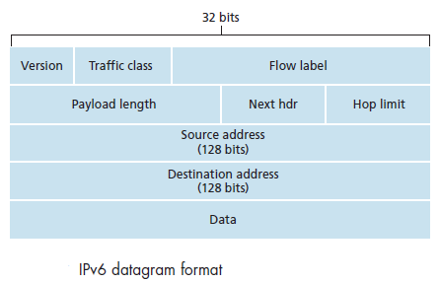

- The fields defined in IPv6 include:
Figure 17

  - Version. The 4-bit field identifies the IP version number.
  - Traffic class. The 8-bit field is similar to the TOS field in IPv4.
  - Flow label. This 20-bit field is used to identify a flow of datagrams.
  - Payload length. This 16-bit value gives the number of bytes in the IPv6 datagram following the fixed-length, 40-byte datagram header.
  - Next header. This field identifies the protocol to which the contents of this datagram will be delivered.
  - Hop limit. The contents of this field are decremented by one by each router that forwards the datagram. If the hop limit count reaches zero, the datagram is discarded.
  - Source and destination addresses. It includes source and destination addresses in 128-bits.
  - Data. This is the payload portion of the IPv6 datagram. When the datagram reaches its destination, the payload will be removed from the IP datagram and passed on to the protocol specified in the next header field.
- Several fields appearing in the IPv4 datagram are no longer present in the IPv6 datagram:
  - Fragmentation/Reassembly. IPv6 does not allow for fragmentation and reassembly at intermediate routers; these operations can be performed only by the source and destination.
  - Header checksum. Because the transport-layer and link-layer protocols in the Internet layers perform checksumming, it is removed in IPV6.
  - Options. An options field is no longer a part of the standard IP header. The removal of the options field results in a fixed-length, 40-byte IP header.

Transitioning from IPv4 to IPv6
- One option would be to declare a flag day—a given time and date when all Internet machines would be turned off and upgraded from IPv4 to IPv6.

- Second approach is dual-stack approach, where IPv6 nodes also have a complete IPv4 implementation. Such a node has the ability to send and receive both IPv4 and IPv6 datagrams.
- In the dual-stack approach, if either the sender or the receiver is only IPv4- capable, an IPv4 datagram must be used.
- As a result, it is possible that two IPv6- capable nodes can end up sending IPv4 datagrams to each other as shown in Figure 18.
- In performing the conversion from IPv6 to IPv4, there will be IPv6-specific fields in the IPv6 datagram. The information in these fields will be lost.
- Thus the arriving IPv4 datagrams at E from D do not contain all of the fields that were in the original IPv6 datagram sent from A.
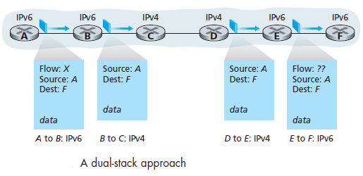
Figure 18
- Another approach known as tunneling can be used to solve the problem of dual-stack approach in the example.
- With tunneling, the IPv6 node on the sending side of the tunnel (for example, B) takes the entire IPv6 datagram and puts it in the data (payload) field of an IPv4 datagram.
- This IPv4 datagram is then addressed to the IPv6 node on the receiving side of the tunnel (for example, E).

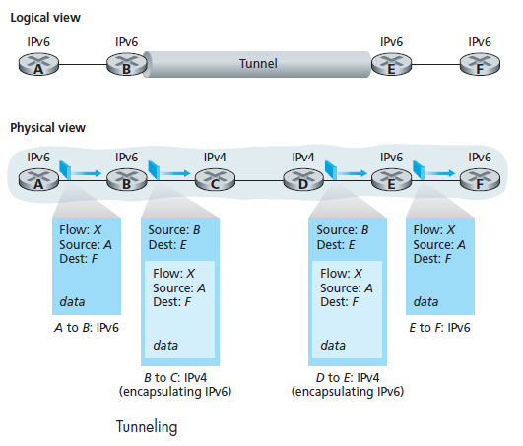Figure 19

A Brief Foray into IP Security
- The services provided by an IPsec session include:
- Cryptographic agreement. Mechanisms that allow the two communicating hosts to agree on cryptographic algorithms and keys.
- Encryption of IP datagram payloads. When the sending host receives a segment from the transport layer, IPsec encrypts the payload. The payload can only be decrypted by IPsec in the receiving host.
- Data integrity. IPsec allows the receiving host to verify that the datagram‟s header fields and encrypted payload were not modified while the datagram was en route from source to destination.
- Origin authentication. When a host receives an IPsec datagram from a trusted source, the host is assured that the source IP address in the datagram is the actual source of the datagram.

Routing Algorithms
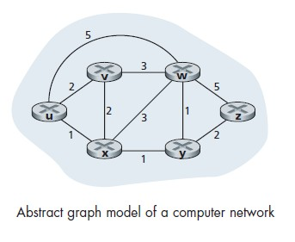
Figure 20
- One way of classifying routing algorithms is whether they are global or decentralized.
  - A global routing algorithm computes the least-cost path between a source and destination using complete, global knowledge about the network. A global algorithm has complete information about connectivity and link costs. Algorithms with global state information are often referred to as link-state (LS) algorithms.
  - In a decentralized routing algorithm, the calculation of the least-cost path is carried out in an iterative, distributed manner. No node has complete information about the costs of all network links. The decentralized routing is called a distance-vector (DV) algorithm.
- A second way to classify routing algorithms is whether they are static or dynamic.
  - In static routing algorithms, routes change very slowly over time. Dynamic routing algorithms change the routing paths as the network traffic loads or topology change.
- A third way to classify routing algorithms is whether they are load sensitive or load- insensitive.
  - In a load-sensitive algorithm, link costs vary dynamically to reflect the current level of congestion in the underlying link. Today‟s Internet routing algorithms (such as RIP, OSPF, and BGP) are load-insensitive, as a link‟s cost does not explicitly reflect its current level of congestion.

The Link-State (LS) Routing Algorithm
- The link-state routing algorithm is known as Dijkstra’s algorithm. Dijkstra‟s algorithm computes the least-cost path from one node to all other nodes in the network.
- The following notations are used:
  - D(v): cost of the least-cost path from the source node to destination v as of this iteration of the algorithm.
  - p(v): previous node (neighbor of v) along the current least-cost path from the source to v.
  - N‟ : subset of nodes; v is in N „ if the least-cost path from the source to v is definitively known.

Link-State (LS) Algorithm for Source Node u
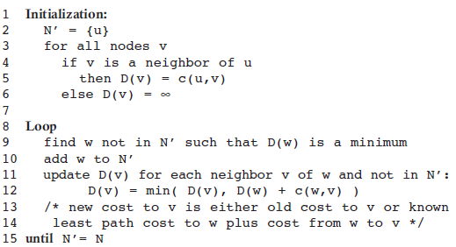
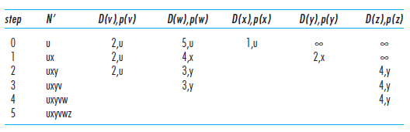
- Figure 21 shows the resulting least-cost paths and forwarding table in u for the network in Figure 20.
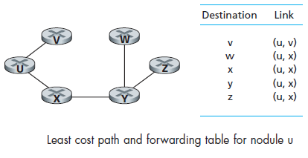
Figure 21

The Distance-Vector (DV) Routing Algorithm
- The distance vector (DV) algorithm is iterative, asynchronous, and distributed.
- It is iterative that the process continues on until no more information is exchanged between neighbors.
- The algorithm is asynchronous in that it does not require all of the nodes to operate in lockstep with each other.
- Let dx(y) be the cost of the least-cost path from node x to node y. Then the least costs are related by the celebrated Bellman-Ford equation, namely,
dx(y) = minv{c(x,v) + dv(y)}
- With the DV algorithm, each node x maintains the following routing information:
  - For each neighbor v, the cost c(x,v) from x to directly attached neighbor, v
  - Node x‟s distance vector, that is, Dx = [Dx(y): y in N], containing x‟s estimate of its cost to all destinations, y, in N
  - The distance vectors of each of its neighbors, that is, Dv = [Dv(y): y in N] for each neighbor v of x
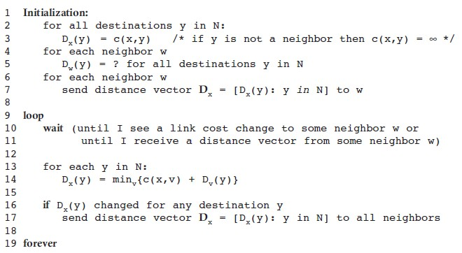
- Figure 22 illustrates the operation of the DV algorithm for the simple three node network shown at the top of the figure.

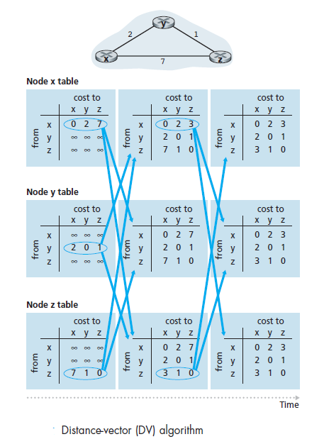
Figure 22

A Comparison of LS and DV Routing Algorithms
- In the DV algorithm, each node talks to only its directly connected neighbors, but it provides its neighbors with least-cost estimates from itself to all the nodes in the network.
- In the LS algorithm, each node talks with all other nodes (via broadcast), but it tells them only the costs of its directly connected links.
  - Message complexity. LS requires each node to know the cost of each link in the network. This requires O(|N| |E|) messages to be sent. Also, whenever a link cost changes, the new link cost must be sent to all nodes. The DV algorithm requires message exchanges between directly connected neighbors at each iteration. When link costs change, the DV algorithm will propagate the results of the changed link cost only if the new link cost results in a changed least-cost path for one of the nodes attached to that link.
  - Speed of convergence. It is seen that implementation of LS is an O(|N|2) algorithm requiring O(|N| |E|)) messages. The DV algorithm can converge slowly and can have routing loops while the algorithm is converging. DV also suffers from the count-to- infinity problem.
  - Robustness. Under LS, a router could broadcast an incorrect cost for one of its attached links. A node could also corrupt or drop any packets it received as part of an LS broadcast. But an LS node is computing only its own forwarding tables; other nodes are performing similar calculations for themselves. This means route
Calculations are separated under LS, providing a degree of robustness. Under DV, a node can advertise incorrect least-cost paths to any or all destinations. An incorrect node calculation can be diffused through the entire network under DV.

Hierarchical Routing
- The model and view of a homogenous set of routers all executing the same routing algorithm is simple for two reasons:
  - Scale. As the number of routers becomes large, the overhead involved in computing, storing, and communicating routing information becomes prohibitive. Storing routing information at each of these hosts would require enormous amounts of memory.
  - Administrative autonomy. An organization should be able to run and administer its network, while still being able to connect its network to other outside networks.
- These problems can be solved by organizing routers into autonomous systems (ASs), with each AS consisting of a group of routers that are under the same administrative control.
- Routers within the same AS all run the same routing algorithm and have information about each other. The routing algorithm running within an autonomous system is called an intra-autonomous system routing protocol.
- One or more of the routers in an AS is responsible for forwarding packets to destinations outside the AS. These routers are called gateway routers.
- Figure 23 provides a simple example with three ASs: AS1, AS2, and AS3. Forwarding table is configured by both intra- and inter-AS routing algorithm.
- Intra-AS sets the entries for internal destinations. Inter-AS & intra-AS sets entries for external destinations.
- Suppose a router, within some AS, want to route a packet to a destination which is outside the AS. The intra-AS routing algorithm determines the least-cost path from internal router to the gateway router to forward the packet.
- The gateway router, upon receiving the packet, forwards the packet on the one link that leads outside the AS. The AS on the other side of the link then takes over the responsibility of routing the packet to its ultimate destination.
- Consider a router in AS1 and suppose it receives a packet whose destination is outside the AS. The router should clearly forward the packet to one of its two gateway routers, 1b or 1c.
- To solve this problem, AS1 needs (1) to learn which destinations are reachable via AS2 and which destinations are reachable via AS3, and (2) to propagate this reachability information to all the routers within AS1, so that each router can configure its forwarding table to handle external-AS destinations.
- These two tasks—obtaining reachability information from neighboring ASs and propagating the reachability information to all routers internal to the AS—are handled by inter-AS routing protocol.
- Suppose that AS1 learns from inter-AS routing protocol that subnet x is reachable both from AS2, via gateway 1b, and from AS3, via gateway 1c.
- The gateway is selected using hot-potato routing approach where a router sends the packet to the gateway router that has the smallest router-to-gateway cost among all gateways with a path to the destination.
- Figure 24 summarizes the actions taken at router 1d for adding the new entry for x to the forwarding table.
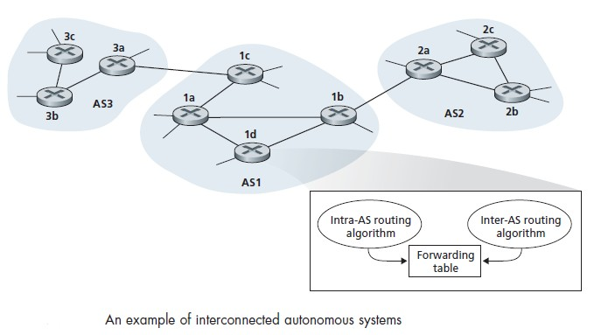
Figure 23
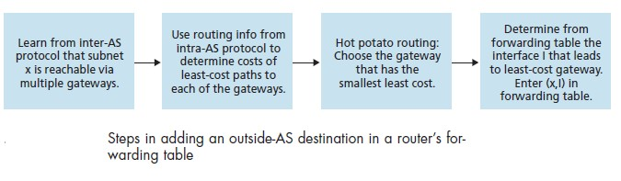

Figure 24

Routing in the Internet
Intra-AS Routing in the Internet: RIP
- Intra-AS routing protocols are also known as interior gateway protocols.
- Two routing protocols have been used extensively for routing within an autonomous system in the Internet: the Routing Information Protocol (RIP) and Open Shortest Path First (OSPF).
- RIP is a distance-vector protocol. Figure 25 illustrates an AS with six leaf subnets. The table in the figure indicates the number of hops from the source A to each of the leaf subnets.
- In RIP, routing updates are exchanged between neighbors approximately every 30 seconds using a RIP response message.
- Response messages are also known as RIP advertisements. Consider the portion of an AS shown in Figure 26.
- Figure 27 shows the routing table for router D. suppose that 30 seconds later, router D receives from router A the advertisement shown in Figure 28.
- Subnet z is only four hops away from router A. Router D, upon receiving the advertisement, merges the advertisement with the old routing table.
- Router D learns that there is a path through router A to subnet z that is shorter than the path through router B.
- Thus, router D updates its routing table to account for the shorter shortest path, as shown in Figure 29.
- Figure 30 shows how RIP is implemented in a UNIX system, for example, a UNIX workstation serving as a router.
- A process called routed executes RIP, that is, maintains routing information and exchanges messages with routed processes running in neighboring routers.
- Because RIP is implemented as an application-layer process, it can send and receive messages over a standard socket and use a standard transport protocol.
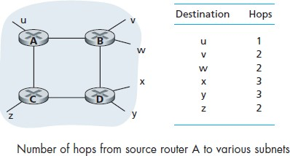
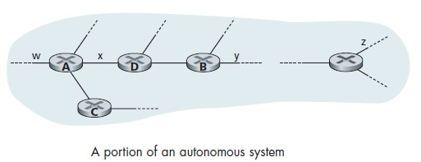
- As shown, RIP is implemented as an application-layer protocol running over UDP.
Figure 25 Figure 26
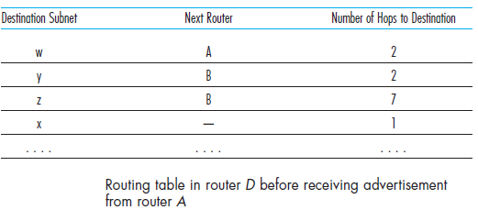
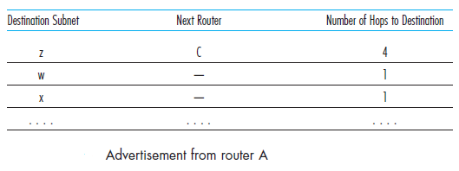
Figure 27 Figure 28
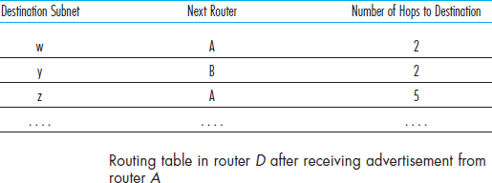
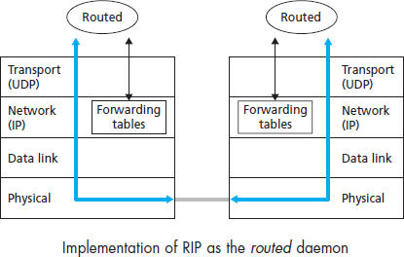

Figure 29 Figure 30

Intra-AS Routing in the Internet: OSPF
- OSPF routing is widely used for intra-AS routing in the Internet.
- OSPF is a link-state protocol that uses flooding of link-state information and a Dijkstra least-cost path algorithm.
- With OSPF, a router broadcasts routing information to all other routers in the autonomous system.
- Some of the advances embodied in OSPF include the following:
  - Security. Exchanges between OSPF routers can be authenticated. With authentication, only trusted routers can participate in the OSPF protocol within an AS.
  - Multiple same-cost paths. When multiple paths to a destination have the same cost, OSPF allows multiple paths to be used.
  - Integrated support for unicast and multicast routing. Multicast OSPF (MOSPF) provides simple extensions to OSPF to provide for multicast routing.
  - Support for hierarchy within a single routing domain. The most significant advance in OSPF is the ability to structure an autonomous system hierarchically.

Inter-AS Routing: BGP
- The Border Gateway Protocol version 4 is the standard inter-AS routing protocol in today’s Internet.
- It is commonly referred to as BGP4 or as BGP. It provides each AS a means to
- Obtain subnet reachability information from neighboring ASs.
- Propagate the reachability information to all routers internal to the AS.
- Determine “good” routes to subnets based on the reachability information and on AS policy.
- In BGP, pairs of routers exchange routing information over semi-permanent TCP connections.
- In Figure 31, there is a TCP connection between gateway routers 3a and 1c and another TCP connection between gateway routers 1b and 2a.
- There are also semi-permanent BGP TCP connections between routers within an AS.
- For each TCP connection, the two routers at the end of the connection are called BGP peers, and the TCP connection along with all the BGP messages sent over the connection is called a BGP session.
- A BGP session that spans two Ass is called an external BGP (eBGP) session, and a BGP session between routers in the same AS is called an internal BGP (iBGP) session.
- Suppose there are four subnets attached to AS2: 138.16.64/24, 138.16.65/24, 138.16.66/24, and 138.16.67/24. Then AS2 could aggregate the prefixes for these four subnets and use BGP to advertise the single prefix to 138.16.64/22 to AS1.

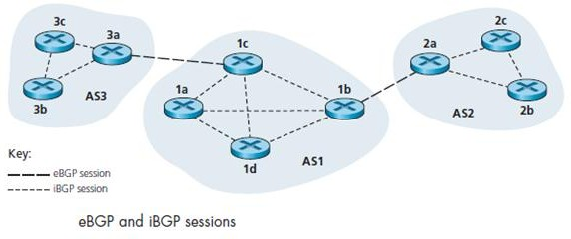
Figure 31

Path Attributes and BGP Routes
- When a router advertises a prefix across a BGP session, it includes with the prefix a number of BGP attributes.
- A prefix along with its attributes is called a route. Two important attributes are AS- PATH and NEXT-HOP:
  - AS-PATH. This attribute contains the ASs through which the advertisement for the prefix has passed. When a prefix is passed into an AS, the AS adds its ASN to the ASPATH attribute. For example in Figure 31, suppose the prefix 138.16.64/24 is first advertised from AS2 to AS1and then to AS3, AS-PATH would be AS2 AS1. Routers use the AS-PATH attribute to detect and prevent looping advertisements.
  - Providing the critical link between inter-AS and intra-AS routing protocols. The NEXT-HOP is the router interface that begins the AS-PATH. In Figure 31, suppose the gateway router 3a in AS3 advertises a route to gateway router 1c in AS1 using eBGP. The route includes the advertised prefix, say x, and an AS- PATH to the prefix. This advertisement also includes the NEXT-HOP, which is the IP address of the router 3a interface that leads to 1c.

BGP Route Selection
- If there are two or more routes to the same prefix, then BGP invokes the following elimination rules until one route remains:
  - Routes are assigned a local preference value as one of their attributes. The policy decision is left to the AS‟s network administrator. The routes with the highest local preference values are selected.
  - From the remaining routes, the route with the shortest AS-PATH is selected. If this is the only rule for route selection, then BGP would use a DV algorithm for path determination, where the distance metric uses the number of AS hops.
  - From the remaining routes, the route with the closest NEXT-HOP router is selected. It determined by the intra-AS algorithm by hot potato routing process.
  - If more than one route still remains, the router uses BGP identifiers to select the route.

Routing Policy
- Figure 32 shows six interconnected autonomous systems: A, B, C, W, X, and Y.
- Assume that autonomous systems W, X, and Yare stub networks and that A, B, and C are backbone provider networks.
- Also assume that A, B, and C, all peer with each other, and provide full BGP information to their customer networks.
- All traffic entering a stub network must be destined for that network, and all traffic leaving a stub network must have originated in that network. W and Y are clearly stub networks.
- X is a multi-homed stub network, since it is connected to the rest of the network via two different providers.
- X is prevented from forwarding traffic between B and C by controlling the manner in which BGP routes are advertised.
- That is, even though X may know of a path, say XCY, that reaches network Y, it will not advertise this path to B.
- Since B is unaware that X has a path to Y, B would never forward traffic destined to Y (or C) via X.
This simple example shows how a selective route advertisement policy can be used to implement customer/provider routing relationships.
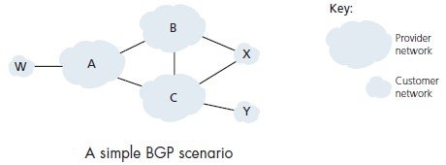
Figure 32

Broadcast and Multicast Routing

- In broadcast routing, the network layer provides a service of delivering a packet sent from a source node to all other nodes in the network.
- Multicast routing enables a single source node to send a copy of a packet to a subset of the other network nodes.

Broadcast Routing Algorithms
- Broadcast communication is for the sending node to send a separate copy of the packet to each destination, as shown in Figure 33(a) which is inefficient.
- It would be more efficient for the network nodes themselves to create duplicate copies of a packet.
- For example, in Figure 33(b), only a single copy of a packet traverses the R1-R2 link.
- The packet is then duplicated at R2, with a single copy being sent over links R2-R3 and R2-R4.

Uncontrolled Flooding
- Flooding approach is the one in which the source node sends a copy of the packet to all of its neighbors as shown in Figure 33
- When a node is connected to more than two other nodes, it will create and forward multiple copies of the broadcast packet, each of which will create multiple copies of itself.
- This broadcast storm, resulting from the endless multiplication of broadcast packets, would result in so many broadcast packets being created that the network would be rendered useless.
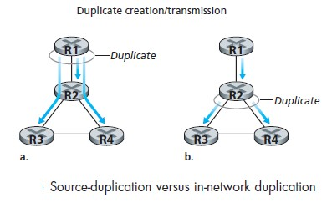
Figure 33

Controlled Flooding
- A broadcast storm can be avoided in one of several ways.
  - In sequence-number-controlled flooding, a source node puts its address as well as a broadcast sequence number into a broadcast packet, and then sends the packet to all of its neighbors.
  - Each node maintains a list of the source address and sequence number of each broadcast packet it has already received, duplicated, and forwarded.
  - When a node receives a broadcast packet, it first checks whether the packet is in this list.
  - If so, the packet is dropped otherwise the packet is duplicated and forwarded to all the node‟s neighbors.
  - The second approach to controlled flooding is known as reverse path forwarding (RPF) also referred to as reverse path broadcast (RPB).
  - When a router receives a broadcast packet with a given source address, it transmits the packet on to its outgoing links only if the packet arrived on the link that is on its own shortest unicast path back to the source.
  - Otherwise, the router simply discards the incoming packet without forwarding it on any of its outgoing links.
  - Figure 34 illustrates RPF. Suppose that the links drawn with thick lines represent the least-cost paths from the receivers to the source (A).
  - Node A initially broadcasts a source-A packet to nodes C and B. Node B will forward the source-A packet it has received from A to both C and D.
  - B will ignore any source-A packets it receives from any other nodes (for example, from routers C or D).

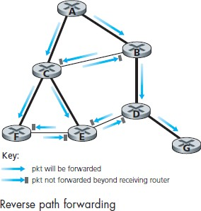
Figure 34

Spanning-Tree Broadcast
- Ideally, every node should receive only one copy of the broadcast packet.
- In Figure 35(a), it is seen that if broadcast packets were forwarded only along links within the tree, each and every network node would receive exactly one copy of the broadcast packet.
- This tree is an example of a spanning trees—a tree that contains each and every node in a graph.
- A spanning tree whose cost is the minimum of all of the graph‟s spanning trees is called a

minimum spanning tree.
- Thus when a source node wants to send a broadcast packet, it sends the packet out on all of the incident links that belong to the spanning tree.
- A node receiving a broadcast packet then forwards the packet to all its neighbors in the spanning tree.
- The spanning tree can be used by any node to begin a broadcast, as shown in Figures 35(a) and 35(b).

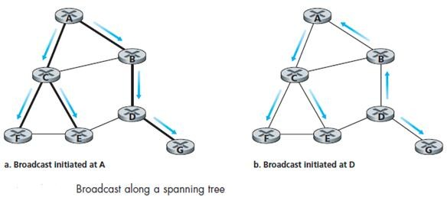
Figure 35
- In the center-based approach to building a spanning tree, a center node is defined.
- Nodes then unicast tree-join messages addressed to the center node.
- A tree-join message is forwarded using unicast routing toward the center until it either arrives at a node that already belongs to the spanning tree or arrives at the center.
- Figure 36 illustrates the construction of a center-based spanning tree. Suppose that node E is selected as the center of the tree.
- Suppose that node F first joins the tree and forwards a tree-join message to E.
- Node B then joins the spanning tree by sending its tree-join message to E.
- Suppose that the unicast path route to E from B is via D.
- Node A next joins the spanning group by forwarding its tree-join message towards E.
- Suppose A‟s unicast path to E is through B. Node C joins the spanning tree next by forwarding its tree-join message directly to E.
- Finally, the unicast routing from G to E must be via node D, when G sends its tree-join message to E.

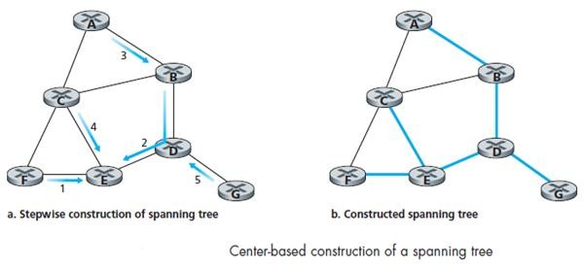
Figure 36

Multicast
- In multicast service, a multicast packet is delivered to only a subset of network nodes.
- The applications include bulk data transfer, streaming continuous media, shared data applications, data feeds, Web cache updating, and interactive gaming.
- A single identifier is used for the group of receivers, and a copy of the packet is delivered to all of the multicast receivers associated with that group using this single identifier.
- In the Internet, the single identifier that represents a group of receivers is a class D multicast IP address.
- The group of receivers associated with a class D address is referred to as a multicast group.
- The multicast group abstraction is shown in Figure 36 where four hosts are associated with the multicast group address of 226.17.30.197 and will receive all datagrams addressed to that multicast address.

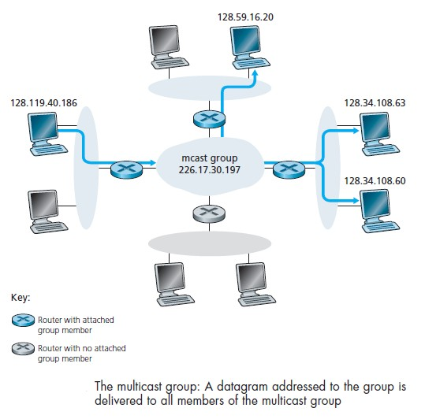
Figure 36

Internet Group Management Protocol
- The IGMP protocol version 3 operates between a host and its directly attached router as shown in Figure 37.
- It shows three first-hop multicast routers, each connected to its attached hosts via one outgoing local interface.
- This local interface is attached to a LAN, and each LAN has multiple attached hosts, where few of these hosts belong to a given multicast group at any given time.
- IGMP provides the means for a host to inform its attached router that an application running on the host wants to join a specific multicast group.
- Network-layer multicast in the Internet consists of two components: IGMP and multicast routing protocols.
- IGMP has only three message types. Like ICMP, IGMP messages are carried within an IP datagram, with an IP protocol number of 2.
- The membership_query message is sent by a router to all hosts on an attached interface to determine the set of all multicast groups that have been joined by the hosts on that interface.
- Hosts respond with an IGMP membership_ report message. membership_report messages can also be generated by a host when an application first joins a multicast group without waiting for a membership_query message from the router.
- The final type of IGMP message is the leave_group message.
- The router infers that a host is no longer in the multicast group if it does not responds to a membership_query message with the given group address.

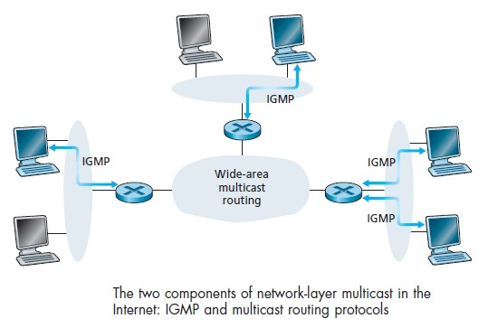
Figure 37

Multicast Routing Algorithms
- The two approaches adopted for determining the multicast routing tree are:
  - Multicast routing using a group-shared tree: multicast routing over a group- shared tree is based on building a tree that includes all edge routers with attached hosts belonging to the multicast group. A center-based approach is used to construct the multicast routing tree, with edge routers with attached hosts belonging to the multicast group sending join messages addressed to the center node.
  - Multicast routing using a source-based tree. While group-shared tree multicast routing constructs a single, shared routing tree to route packets from all senders, the second approach constructs a multicast routing tree for each source in the multicast group. An RPF algorithm is used to construct a multicast forwarding tree for multicast datagrams originating at source x. consider router D in Figure
38. Under broadcast RPF, it would forward packets to router G, even though router G has no attached hosts that are joined to the multicast group. The solution to the problem of receiving unwanted multicast packets under RPF is known as pruning. A multicast router that receives multicast packets and has no attached hosts joined to that group will send a prune message to its upstream router. If a router receives prune messages from each of its downstream routers, then it can forward a prune message upstream.

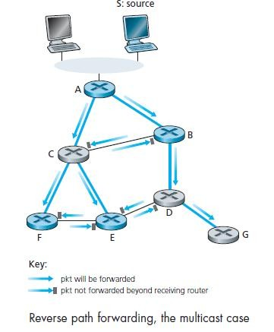
Figure 38

Multicast Routing in the Internet

- The first multicast routing protocol used in the Internet was the Distance-Vector Multicast Routing Protocol (DVMRP).
- DVMRP implements source-based trees with reverse path forwarding and pruning.
- The most widely used Internet multicast routing protocol is the Protocol-Independent Multicast (PIM) routing protocol, which explicitly recognizes two multicast distribution scenarios.
- In dense mode, multicast group members are densely located. PIM dense mode is a flood-and-prune reverse path forwarding technique similar in spirit to DVMRP.
- In sparse mode, the number of routers with attached group members is small with respect to the total number of routers; group members are widely dispersed.
- PIM sparse mode uses rendezvous points to set up the multicast distribution tree.
- In source-specific multicast (SSM), only a single sender is allowed to send traffic into the multicast tree, considerably simplifying tree construction and maintenance.
- The Multicast Source Discovery Protocol (MSDP) can be used to connect together rendezvous points in different PIM sparse mode domains.

